Online Shopping System: FootFusion

Use-Case-Realization Specification: Delete Payment Methods

Version <1.0>

Revision History
Date | Version | Description | Author
23/11/2024 | 1.0 | Final Draft | Nguyen Minh Duc

Table of Contents
1. Introduction 2
1.1 Purpose 2
1.2 Scope 2
1.3 Definitions, Acronyms, and Abbreviations 2
1.4 References 2
1.5 Overview 2
2. Flow of Events—Design 2
3. Derived Requirements 2

Use-Case-Realization Specification: Delete Payment Methods

Introduction

Purpose
In terms of cooperating objects, this document explains how the Delete Payment Methods Use-Case is implemented inside the design model.

Scope
This document pertains to the FootFusion platform, our website that is currently being developed for shoe-selling.

Definitions, Acronyms, and Abbreviations
Administrator: The person managing content and features of the FootFusion website.

References
Use Case Specification – Delete Payment Methods.

Overview
The Use-Case Realization Specification of the FootFusion's Add Payment Methods Use-Case is detailed in the part that follows. The Use-Case definition is described in text form in the first section. A sequence diagram outlining the use case's realization in terms of cooperating objects and class diagrams with relationships that contribute to its realization may be found in the section that follows. All requirements are analyzed in the final part. They need to be addressed during implementation, but are not taken into account in the design model for the use-case realization.

Flow of Events—Design
Administrator has to log-in by the administrator account to perform the task.

Sequence Diagram
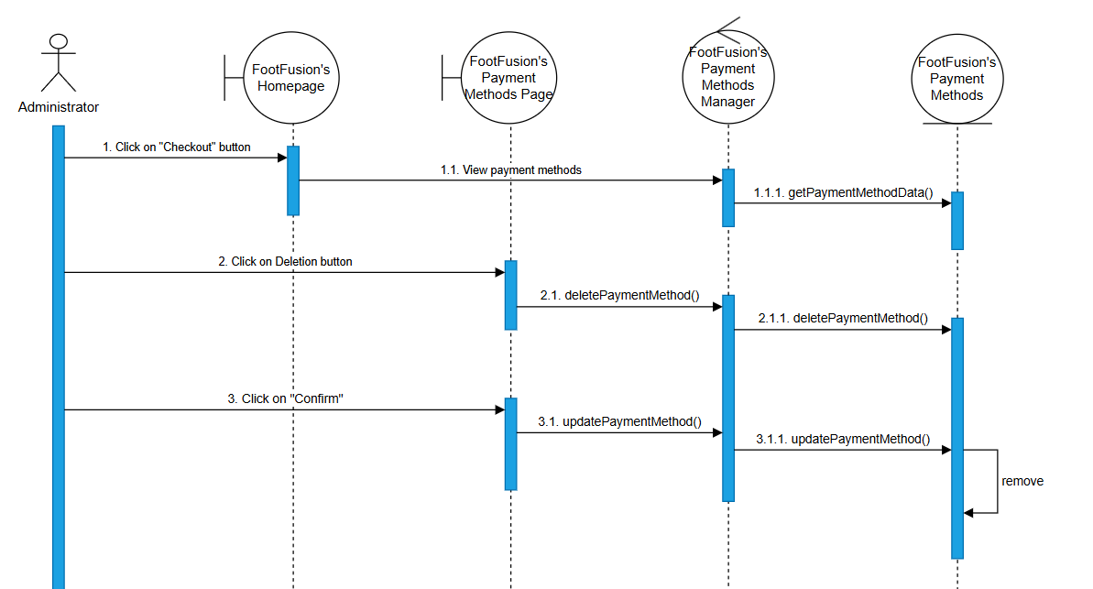

Class Diagram
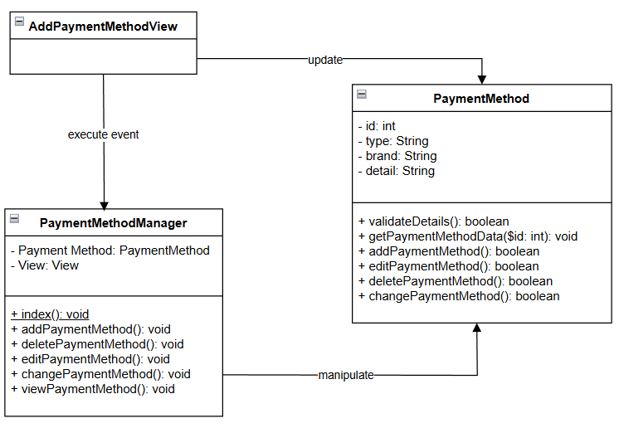

Derived Requirements
There is no derived requirement.

